Term 5 – Week 4 Enquiry
Art and Music
Have a look at this picture.
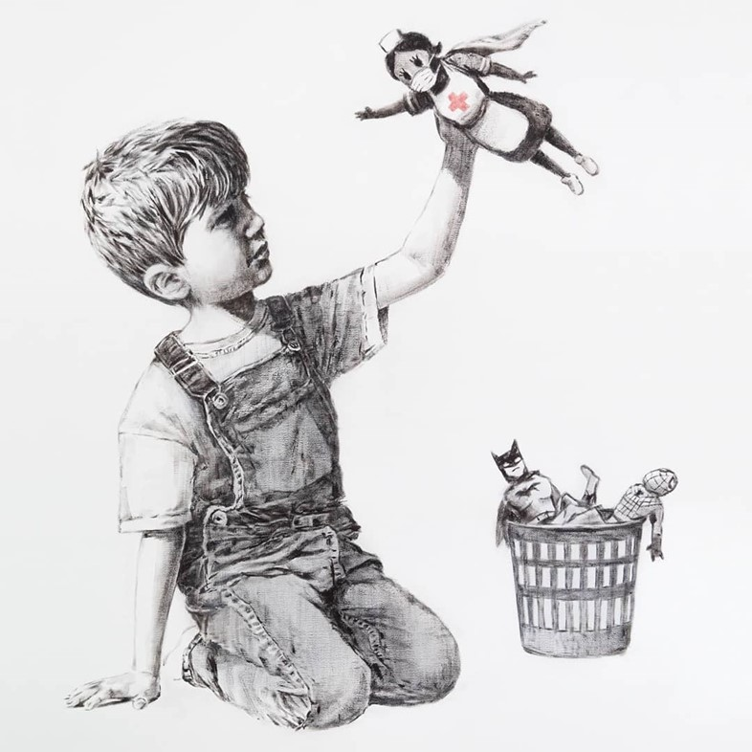

It is by an artist from Bristol, called Banksy. Talk to your family about what you think Banksy is trying to make us think about.
Find some of your favourite toys and have a go at drawing them.

Have a go at singing and signing to this song !
https://www.youtube.com/watch?v=wCfjV_G_x5s

