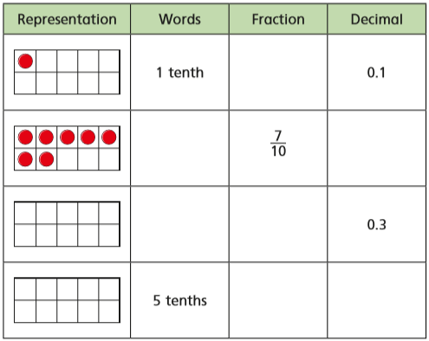
- Complete the table by writing what should go in the boxes in your book.
g)
f)
e)
d)
c)
b)
a)
- What decimal numbers are shown by these counters?
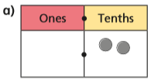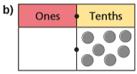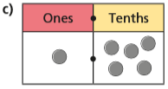
- What decimal number are the arrows pointing to?
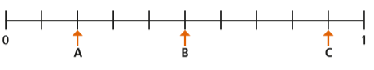
Can you also write each decimal as a fraction?
- Put these fractions, decimals and words in order from smallest to biggest:
Two tenths | $$\frac{9}{10}$$ | 0.7 | One whole | 0.4 | $$\frac{1}{10}$$

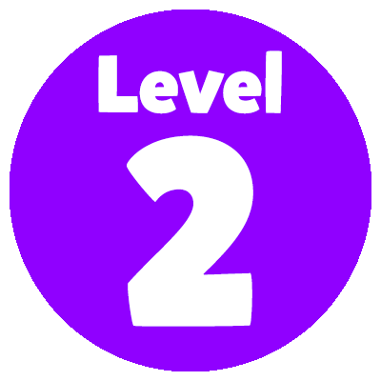
Jackob places all these counters somewhere on the grid.
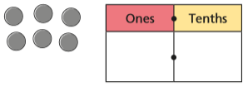
List all the possible numbers he could be representing.

Wednesday 10th June - Maths

